Practical 4
Aim : Study and Install Bitcoin Wallet.

Bitcoin Wallet :
A Bitcoin wallet is a software or hardware application used to store, receive, send, and manage Bitcoin (BTC). It does not actually store Bitcoin; it stores the private keys that give access to Bitcoin recorded on the blockchain.

Step 1 : Download the wallet only from
https://bitcoin.org/en/choose-your-wallet
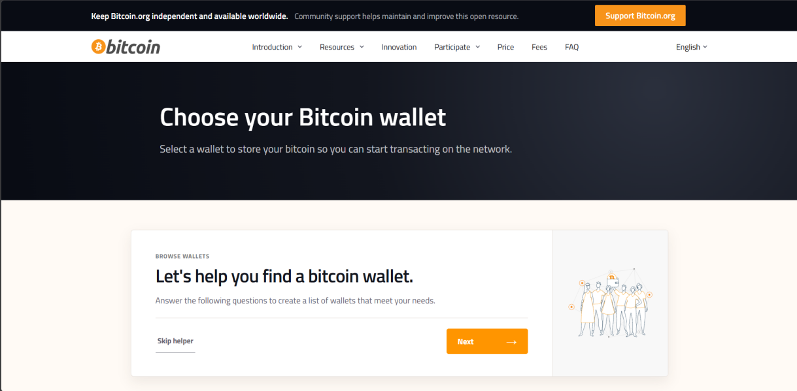
Step 2 : Choose OS.
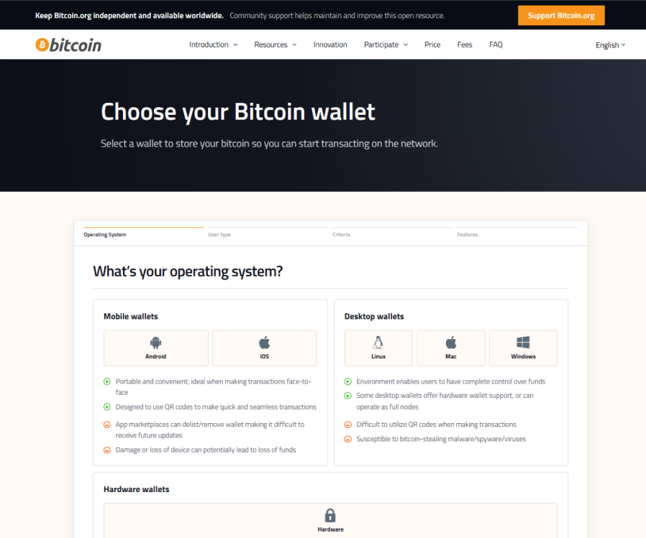
Step 3 : Put some preferences (Optional).
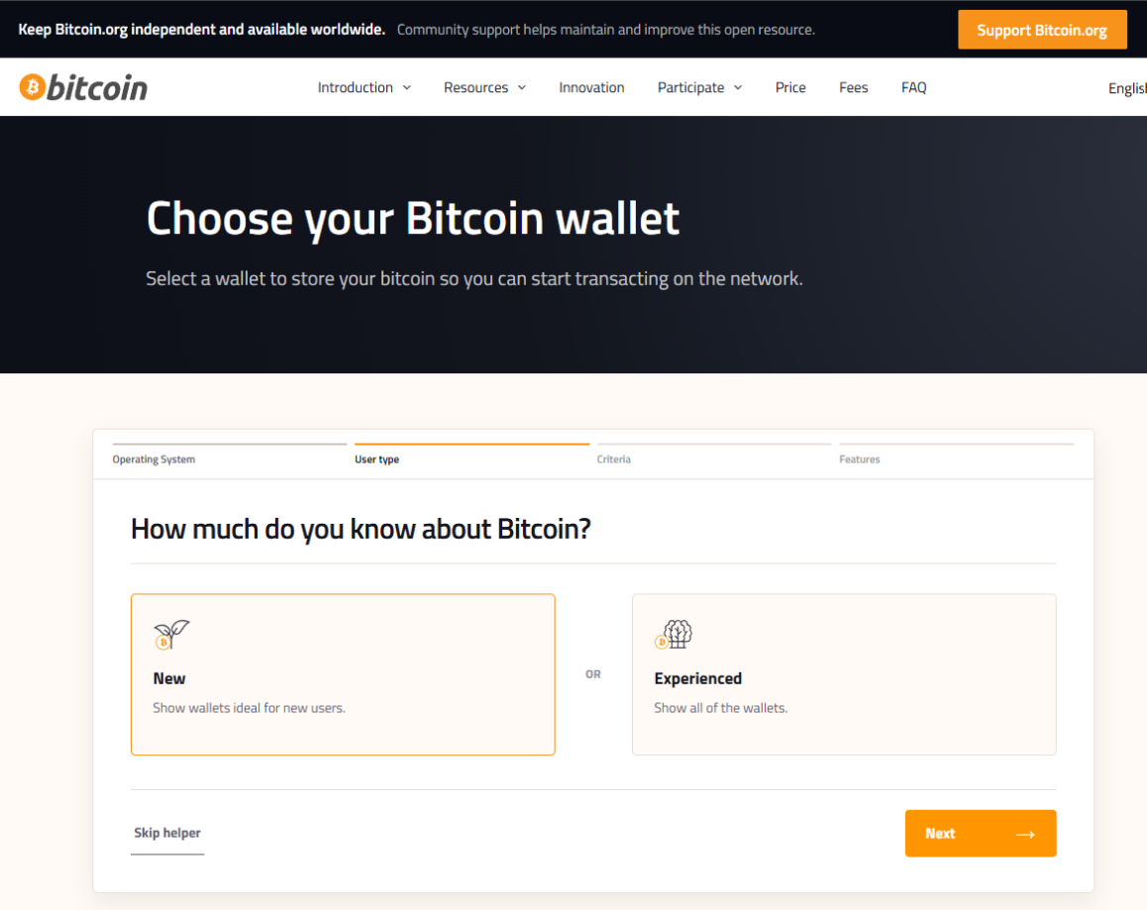
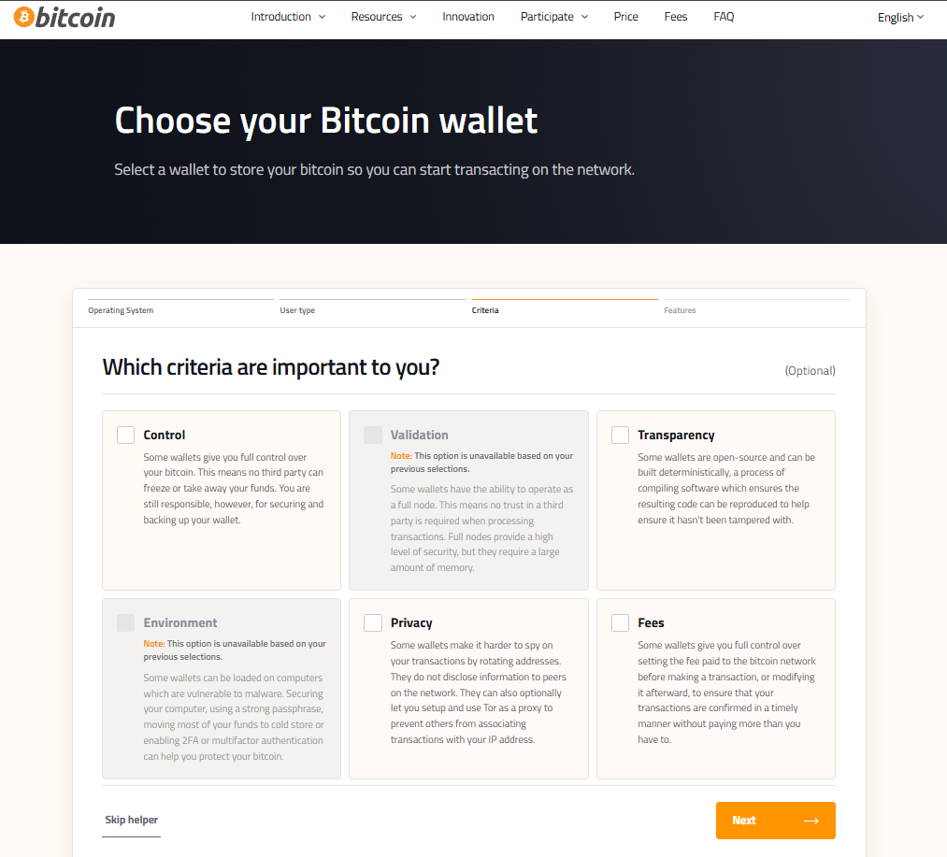

Step 4 : Choose a wallet from the list.
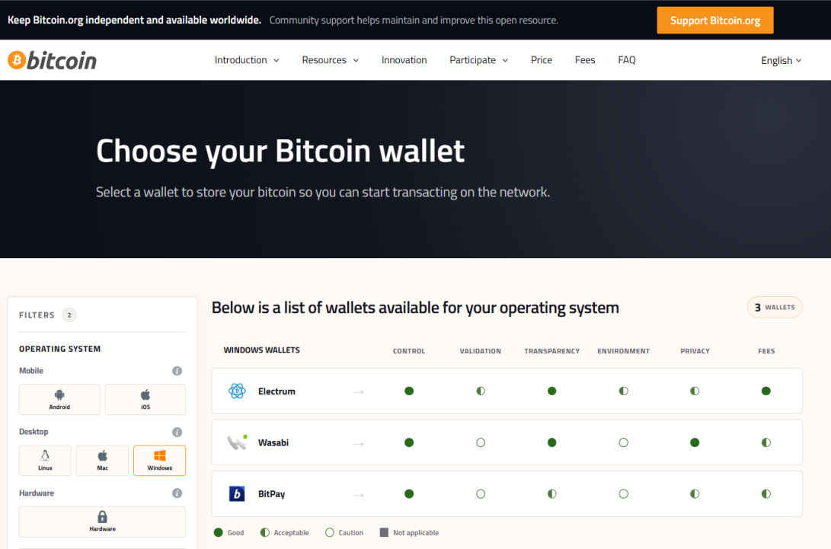
Step 5 : Here we have chose Wasabi.
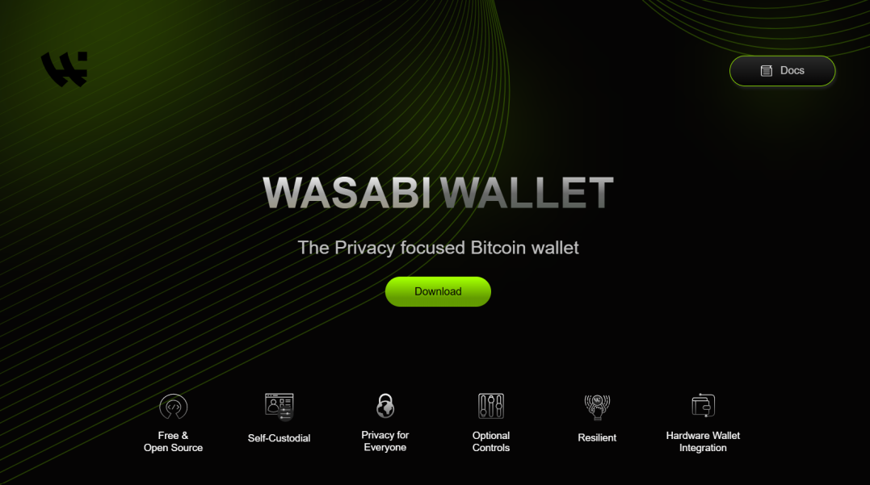
Step 6 : Setup Wasabi.
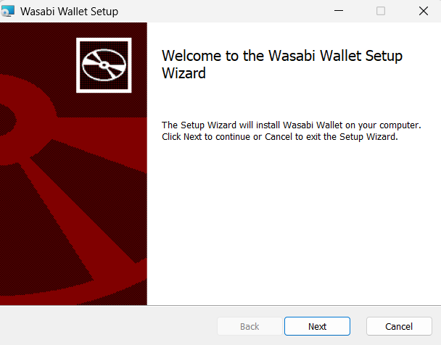
Step 7 : Open Wasabi.
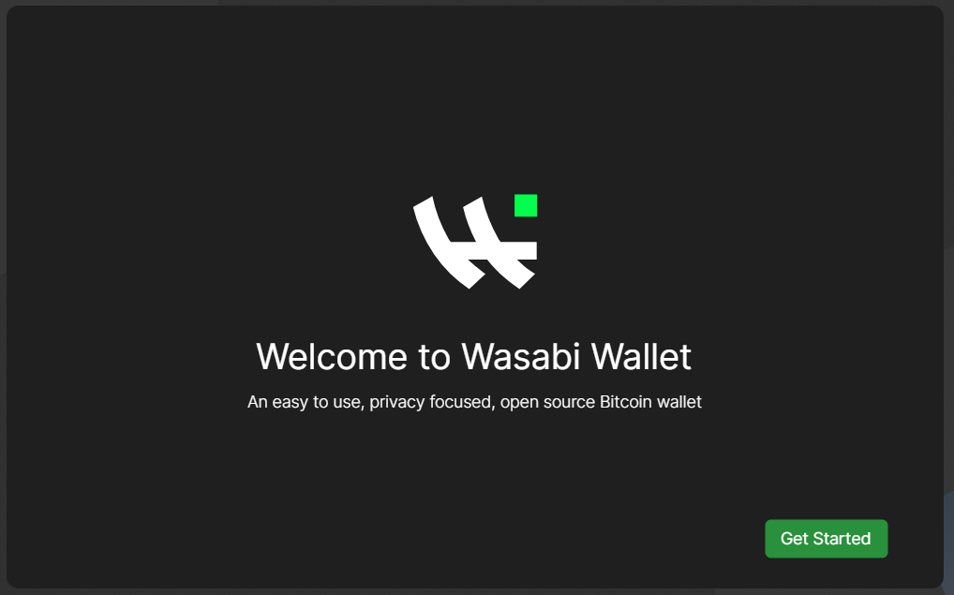
Step 8 : Create new wallet.
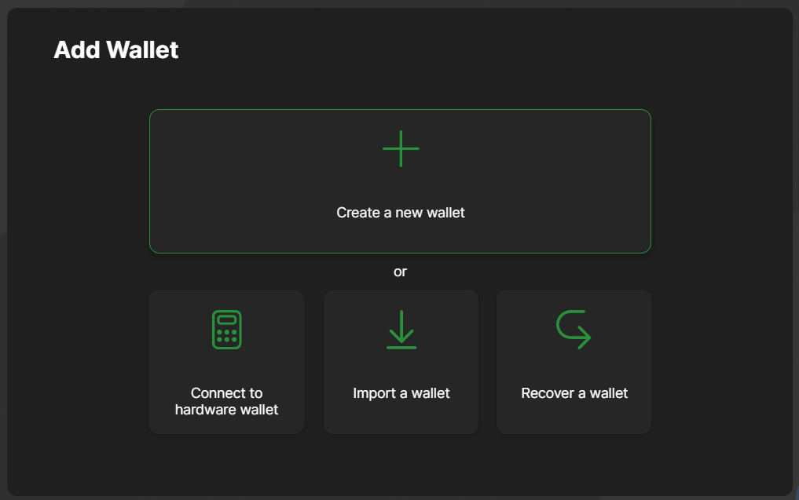
Step 9 : Add passphrase.
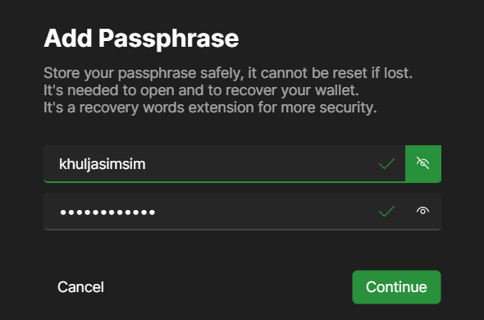
Step 10 : Wallet is created.
